

Before completing this form, please ensure that your event/activity has been confirmed on the Mighty River Domain/Lake Karāpiro event calendar and that you have read the current Event Management Manual. You can contact the Site Manager on info@lakekarāpiro.co.nz to discuss this further.

A draft of this form must be received by Mighty River Domain no later than 12 weeks prior to the event and a final and completed form must be received no later than 6 weeks prior to the event.

Applications must be sent to info@lakekarāpiro.co.nz in the first instance. If there is a maritime request this will be forwarded to the Waikato Regional Council by Site Management.

If you require assistance with your booking or forms, contact info@lakekarāpiro.co.nz

*Please note: you will be invoiced by Waipa District Council on completion of the event for bookings of facilities at the domain as per the prices in the Event Management Manual.*

*This application form includes:*

**•**

**•**

**•**

**•**

**•**

**•**

**•**

**•**

**•**

**•**

**•**

**•**

**SECTION 1 – Contact Details SECTION 2 – Event Details**

**SECTION 3 – Key Personnel and Contractors SECTION 4 – Ground and Land requirements SECTION 5 – Function Room requirements**

**SECTION 6 – Accommodation requirements**

**SECTION 7 – Traffic Management and Parking SECTION 8 - Waste Management**

**SECTION 9 - Event Operations**

**SECTION 10 - Safety Management SECTION 11 – Maritime Use**

**SECTION 12 - Declaration**

Temporary Event Application

Page 1

**Organisation:**

**Legal status:** (limited liability/charity/incorporated society etc.)

**Postal address:**

**Main contact:**

**Position:**

**Email:**

**Mobile phone:**

**Event WWW:**

**Brief description of organisers experience:**

**Event name:**

**Event date:**

**Set up date:**

**Pack out date:**

**Brief description of the event:**

Temporary Event Application

Page 2

**SECTION 2 - Event Details**

**SECTION 1 - Contact Details**

**Expected number of participants:**

**Expected number of spectators:**

**Please list the sponsors that are associated with your event:**

**Is your event sanctioned by a national or international body?**

***If Yes, who?***

**List your social media accounts associated with the event:**

Event organisers are required to have sufficient public liability insurance while holding an event on Waipa District Council premises. There will be no exceptions and Lake Karāpiro management reserve the right to view this documentation.

*I agree that we have appropriate public liability insurance cover for my activities. Please find attached certificate.*

Temporary Event Application

Page 3

It is your responsibility to establish safe practices for people who will be carrying out duties under your control. While you are responsible for the safety of all your personnel and equipment Site Management reserves the right to consult on any procedures involving safety.

All key personnel and contractors are required to have the appropriate training, experience and/or qualifications to undertake their role. Please include relevant experience in your application form. They are also required to check into the site’s SINE account while on site. This can take place at the Site Office or an IPad can be provided to the organiser on request.

Site management will not accept any damage to any Waipa District Council property. All areas are to be reinstated to their original condition and any damage or repair costs will be passed onto event organisers.

**List all key personnel, their allocations of responsibilities, location where operating and contact details:**

Any contractors that you engage with to be on site must be SHE approved. to engaging with any contractors who do not meet this requirement.

Contact Site Management PRIOR

**List of all contractors onsite during setup/event days/breakdown:**

Temporary Event Application

Page 4

**COMPANY**

**SERVICE PROVIDED**

**SHE APPROVED NUMBER**

**NAME:**

**ALLOCATIONS/RESPONSIBILITIES**

**LOCATION OF CONTROL**

**PHONE**

**Event manager**

**On-water controller**

**On-land controller**

**Traffic controller**

**Parking controller**

**Biosecurity controller**

**SECTION 3 - Key Personnel and Contractors**

Please specify any other land areas you would like to book *(see site map in Event Management Manual).*

**Are there any other land areas you are requesting to use:**

Temporary Event Application

Page 5

**ZONE**

**DESCRIPTION**

**DATES OF USE**

**No. OF DAYS**

**HOURS OF USE**

**A5**

**Lower camp ground**

**B2**

**Upper camp ground**

**E2**

**Spectator embankment**

**D2**

**Rear of Lodge lawn**

**D1**

**Front of Lodge lawn**

**C1**

**Back of Tower**

**G1**

**Car park 1**

**G2**

**Car park 2**

**A10**

**Judd Lane**

**Sir Don Rowlands Centre**

**Asphallt Carpark**

*\*Note this is only available if you book the main hall OR the main hall is not booked by another user.*

**SECTION 4 - Ground and Land Requirements**

**Will you be requiring any rooms in the Sir Don Rowlands Centre?**

**YES**

**NO**

*If* ***YES****, Please select rooms requested and fill in a Sir Don Rowlands Centre Booking Form.*

**Will you be requiring any accommodation?**

**YES**

**NO**

*If* ***YES****,*

*Please select rooms requested and fill in an Accommodation Booking Form.*

Temporary Event Application

Page 6

**ROOM**

**CHECKING IN**

**CHECKING OUT**

**No. OF GUESTS**

**Rob Waddell Lodge (max 41pax)**

**Chalet 1 (max. 8pax)**

**Chalet 2 (max. 8pax)**

**Chalet 3 (max. 8pax)**

**Chalet 4 (max. 8pax)**

**Chalet 5 (max. 8pax)**

**SECTION 6 - Accommodation**

**AREA**

**DATE OF HIRE**

**Main Hall**

**Servery/ Foyer**

**Main Kitchen**

**Karāpiro Room**

**Waipa Room**

**Te Manawa o Matariki Room**

**Drug Testing Room**

**First Aid Room**

**Perry Community Water Sports Centre (Canoe Room)**

**SECTION 5 - Function Rooms**

Traffic Control refers to the management of traffic on Maungatautari Road for all road users to safely enter, exit and pass through the site.

Parking refers to the management of vehicles once they have entered the site (still public roads) which includes any collection of any gate fees, managing restricted areas and the efficient parking of vehicles in approved areas.

Vehicle movement refers to the movement of event or public traffic with in the domain public roads (any road inside the physical gates at Gate 1, 2 and 3.

**Traffic Control**

Ensure you have read the Event Management Manual to understand your obligations for the management of traffic generated by your event (in and around the site).

In accordance with the Event Management Manual – Please ensure you attach a traffic control plan and have completed the online questionnaire.

**Completed traffic control plan and online questionaire?**

**YES**

**NO**

**Who will you be using to control your traffic on the Maungatautari Road?**

**Who will you be using to manage your internal parking and manage public internal roads?**

How will you manage /restrict traffic within the site to eliminate any vehicle movements during your event? **Will you be closing any of the site internal roads or areas where public are prohibited? If YES, how will you do this and what times?**

**What time will the main embankment be closed for vehicle movements:**

Unless specifically agreed with the Site Manager, no vehicles are permitted on the grassed embankment or Main Embankment.

Temporary Event Application

Page 7

**SECTION 7 - Traffic Control and Parking**

**Will you have any official vehicles operating within the site?**

**YES**

**NO**

**List any vehicles and safety measures in place.**

What areas are you using for parking? (refer to site map) and list who is permitted in each area (i.e. officials in lodge ground, public in G1, G2 etc.). All areas should be included in Section 4. *Note. Unless agreed otherwise the site office/café carpark must remain free at all time with Site and Café staff requiring access at all times.*

**What are your parking contingency plans?**

**i.e. if you need more or if weather prohibits the use of some of the grounds.**

**How will your parking team, traffic management team communicate with you and site management?**

The event is required to actively minimize the waste generated by all those attending the event. Mighty River Domain is progressing to zero-waste in 2025. To plan for this the event must provide a Waste Management plan. If this plan is approved by Site Management, we will support your plan with the supply of general, recycling, glass and food waste bins and will agree on a removal plan *(charges may apply – see Event Management Guide)*. You will be responsible for any human resource required to supervise your plan and any post event site cleaning costs incurred by the Site Management.

**We’ve planned to actively minimize the waste generated by the event.**

**I have attached the event’s waste management plan.**

**YES**

**YES**

Temporary Event Application

Page 8

**SECTION 8 - Waste Management**

**EVENT GROUP**

**PARKING AREA**

**Public/ Spectators**

**Competitors**

**Officials**

**Disability Card Holders**

**VIPs**

**Café Only Patrons**

**Security and Gate Access**

**Does your site planning always allow access to all areas by emergency service vehicles?**

**Will you have event security on site?**

***If YES, who and what times and what is their brief?***

**Will you be allowing public access to the domain boat ramp during your event?**

***If NO, how will you manage this?***

**Communications**

**Provide details of how you will be communicating between your key staff and how key areas will stay connected through the event? Mobile phones, radios? Provide details how your carparking team will be communicating with each other and with event management.**

**Signage**

**List any directional signage, warning or other signs that will be erected on site:**

Temporary Event Application

Page 9

**SECTION 9 - Event Operations**

**Power Requirements**

All electrical equipment brought to the site is required to have a current “Tag and Test” certification. Any connections to venue sourced power require the attendance of an approved Electrician.

**Are you requesting to use any venue sourced power?**

**YES**

**NO**

**Are you bringing any temporary power sources to the venue?**

**YES**

**NO**

**List any access to the existing site power sources (not including standard household plugs) that will be required or any other temporary power sources that will be on site.**

**Sound**

Amplified sound is permitted in line with the Event Management manual.

**Are you using any amplified sound?**

**YES**

**NO**

*I agree that these will be operated within the limits and times indicated in the event management manual.*

**Please indicate the location of any permanent or temporary speakers that will be used on your site map. Confirm you are aware of and agree to the noise conditions as per the event management manual.**

Temporary Event Application

Page 10

**Temporary Structures**

**Are you bringing in any temporary structures?**

***i.e. tents, marquees, portacoms, cabins***

**YES**

**NO**

**List all temporary structures that will be brough to site and include position on site map. bigger than 100sqms will require Council consent and any safety measures in place.**

**Any marquees**

**Machinery**

**Are you bringing in any machinery or other large structures?**

**YES**

**NO**

**List any machinery (cranes, scissor lifts, big screens etc) and any safety measures in place.**

**Vehicles**

**Will you have any official vehicles operating within the site?**

**YES**

**NO**

**List any vehicles and safety measures in place.**

Temporary Event Application

Page 11

**Food Vendors**

**Will you have any food vendors on site?**

**YES**

**NO**

*I confirm they meet all safety and food standard permits.*

**List any food vendors.**

**MISC. EQUIPMENT**

**Please indicate if you wish to hire any of the following equipment that the site can offer *(prices on application)*:**

**Additional Traffic Cones**

**Rope and Standards Picket Fence**

**Water Hoses**

Temporary Event Application

Page 12

The Event and Site Management are required to provide an environment that plans to keep those attending the site and event safe and are required by law, to consult, coordinate and cooperate when working together on site.

The Event Management Guide includes the risks associated with the site and the mitigations and responsibilities of both the Site Management and the event. The event is required to supply a SITE specific Health and Safety Plan that includes the comprehensive Risk Register with specific risks identified and eliminated or mitigated. If any shared risks have been identified, site management will work with you to ensure appropriate mitigation have been applied.

You can more on your obligations and managing risk here: http[s://www.worksafe.govt.nz/managing-health-and-safety/managing-risks/](http://www.worksafe.govt.nz/managing-health-and-safety/managing-risks/)

**YOU WILL BE REQUIRED TO:**

**1.**

**PRODUCE A SITE SPECIFIC DETAILED MAP OF THE VENUE AND YOUR EVENT DETAILS.**

This must include public and restricted event spaces.

Please number each section of your map and have a detailed explanation of each space and attach a specific risk register for each event space.

Explain how each internal road will be utilised and what traffic movements will occur in each specific event space.

2.

3.

*I understand the risks associated with the event and the site and I have considered the health and safety of all those associated with the event.*

*I have attached the event’s Health and Safety Plan (including a specific risk register).*

*I understand that the Event can be attended by a Council H&S officer who could undertake an audit at any time and that I will act on any instructions.*

*I understand that I will be required to meet with Site Management daily (time to be agreed).*

**First Aid**

**Have you considered the health and safely of all those attending the event in your first aid planning and response?**

**YES**

**NO**

**Summarise your first aid response below and include the name of any contractor provider *– please read the Event Management Guide for minimum requirements.***

Temporary Event Application

Page 13

**SECTION 10 - Health and Safety**

**Biosecurity**

Please provide your Biosecurity management plan *(as an attachment)* to help stop the spread of pests in the Waikato River.

**Where will your vessel washing station be located?**

**Name of your Controller:**

Your plan should include how you intend to CHECK, CLEAN and DRY all vessells leaving the lake domain. Please include how you are communicating the CCD messaging and protocols to your participants.

Temporary Event Application

Page 14



Complete this section only if you are intending to conduct a race, speed trial, competition, or any other organised recreational water activity on any water ways in Lake Karāpiro. If you are not using any water please continue to section 12. If you require assistance with this section please contact Pamela Copeland on [pamela.copeland@waikatoregion.govt.nz](mailto:pamela.copeland@waikatoregion.govt.nz)

Application is under clause 5.6 of the Waikato Regional Council Navigation Safety Bylaw 2013.

**Public notification**

Your application will be publicly notified between seven and fourteen days prior to your event as outlined in clause 5.6 of the Waikato Regional Council Navigation Safety Bylaw 2013. The purpose of this notification is to let other users know this area is reserved for your use. The cost of the public notice is additional to the processing fee and will be invoiced to you at the time of the notice.

**Authorisation fee**

The fee for processing an authorisation for a temporary maritime event is $130.00 excl GST as specified in the Waikato Regional Council’s Annual Plan, public notification costs are additional. The authorisation fee must be included with your application.

**In developing the events Health and safety Plan the following is required to be included specific to the use of water:**

•

Analysis of all risks and hazards involved in the event and what measures will be used to eliminate, isolate or minimise these

Numbers and types of vessels and/or people involved Map of event course(s) and required reserved areas

Numbers and types of patrol/marshal/safety vessels and how they will be used to manage risk including preventing unauthorised vessels from entering any reserved areas

Details of any significant safety incidents from previous events within New Zealand in the last 5 years A communications plan

Schedule of safety briefings and key messages

Justification for any reserved areas and bylaw uplifting requested Qualifications and /or experience of event organiser and event safety officer Contact details of event organiser and event safety officer

Insurance held for the event

Affiliations to any national bodies that oversee the event or standards that apply to the event Average and maximum vessel speeds involved

Weather limits for event.

•

•

•

•

•

•

•

•

•

•

•

•

•

Temporary Event Application

Page 15

**SECTION 11 - Maritime (Water Use) Application**

**Public notification**

It is important to state the hours of use, as public have the right to use water outside of hours booked. It is not expected that bookings will extend beyond 6pm under normal circumstances.

**Please list all requested use and times, include set up and pack down time and specify any reserve dates required on water.**

**Description of water-based activities (please use separate sheet if necessary):**

**What clause(s) of the bylaw would you like uplifted for your event?**

**Maximum number of participants/vessels:**

**Name of Controller of on-water activities**

**On-water Controller cellphone number:**

**Name of Manager of on land activities**

**On-land Manager cellphone number:**

Temporary Event Application

Page 16

**REQUESTED ZONES**

**REQUESTED DATES OF USE**

**REQUESTED HOURS OF USE**

**(Start and Finish Time)**

**Zone 1**

**Zone 2**

**Zone 3**

**Zone 4**

**Zone 5**

**Zone 6**

**Zone 7**

**Zone 8**

**Zone 9**

**Declaration**

I, declare that as applicant, or on behalf of the applicant, that:

*•*

*•*

*I have read and agree with the information in the Event Management Manual.*

*I agree a minimum charge of an Event Booking Fee of $185.00 applies to all bookings (payable to Waipa District Council). Additional grounds, accommodation and conference room charges apply.*

*I understand that the public have the right to use water and grounds outside of hours booked. It is not expected that bookings will extend beyond 6pm under normal circumstances.*

*I acknowledge that it is my responsibility to establish safe practices for people who will be carrying out duties under my control and that Site Management reserves the right to consult on any procedures involving safety.*

*I acknowledge the site specific underground services map and have forwarded to all event personal and external contractors.*

*I acknowledge that I am responsible for the safety of all your personnel and equipment.*

*I acknowledge that Site Management will not accept any damage to any Waipa District Council property. All areas are to be reinstated to their original condition and any damage or repair costs will be passed onto event organisers.*

*•*

*•*

*•*

*•*

*•*

*I understand, acknowledge and agree.*

**For Maritime Applications only:**

*•*

*I agree a Maritime Booking fee of $130.00 excl GST applies to all events requesting water use (payable to Waikato Regional Council).*

*I am authorised to act as the applicant for the purpose of the temporary maritime event and that the information supplied is true and correct.*

*As the applicant for the temporary maritime event, I will implement strategies to alleviate all risks associated and that Waikato Regional Council is indemnified and released from all liability in this regard.*

*I agree the maritime event/activity will be run in accordance with all conditions required by Waikato Regional Council.*

*I agree to pay all costs incurred for the public notification’s requirements of this application.*

*I acknowledge that if in the opinion of the Harbourmaster (or representative), the event is not managed safely, the Harbourmaster (or representative) may cancel the event at any stage, and the Council will not have any liability for any losses incurred by the event organiser or competitors/participants as a result of any cancellation.*

*The information I have supplied may be available to any person who enquires in accordance with the Local Government Official Information and Meetings Act 1987 and the Privacy Act 1993.*

*I understand that to prevent the spread of serious aquatic pests such as didymo and other aquatic weeds you must check, clean dry your boats and gear when going from one waterway to another to remove any spores and/or fragments of weed and we will pass this information onto our competitors.*

*For more information visit* [*www.biosecurity.govt.nz.*](http://www.biosecurity.govt.nz/)

*•*

*•*

*•*

*•*

*•*

*•*

*•*

*I understand, acknowledge and agree.*

**Position in club, organisation, association:**

**Signature:**

**Date:**

**Director of company, trust or organisation:**

**Name of company, trust or organisation:**

**Signature:**

Temporary Event Application

Page 17

**Checklist**

*I have completed the full application.*

*I have attached a valid insurance certificate.*

*I have attached a safety management plan (including a Risk Register).*

*I have completed the online traffic control questionnaire and submitted.*

*I have attached a waste management plan.*

*I have attached a biosecurity plan.*

*I have attached a site specific detailed plan.*

Temporary Event Application

Page 18

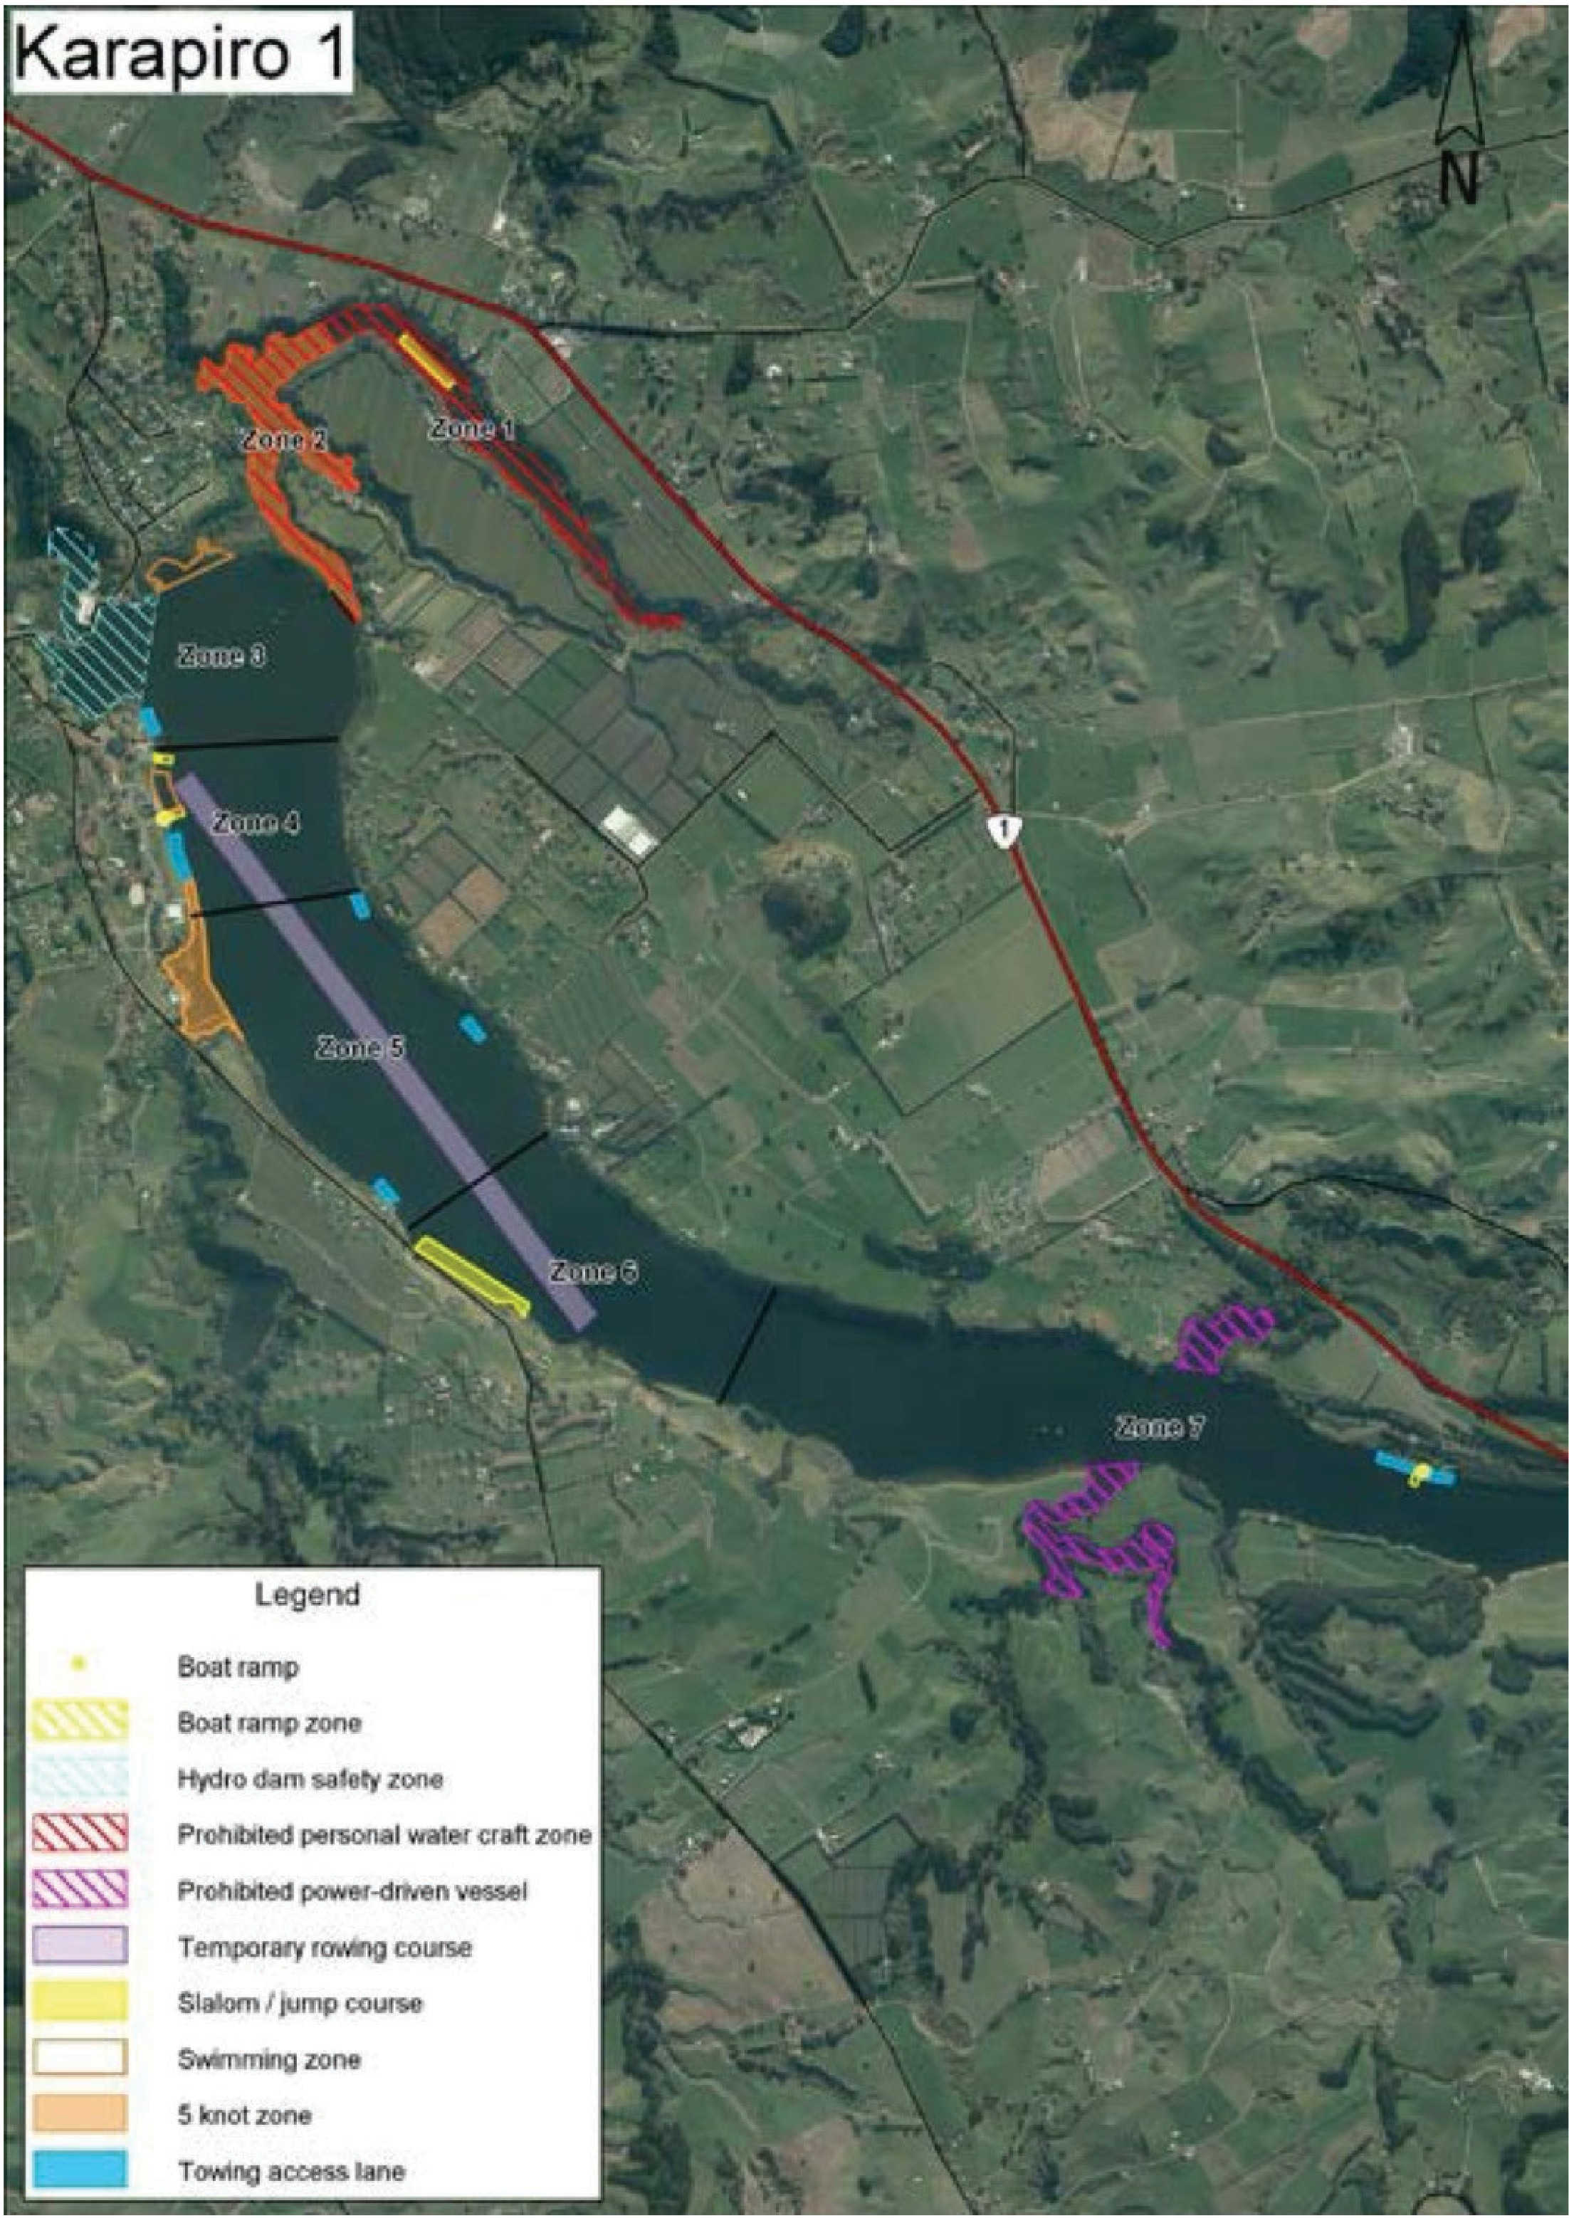

Temporary Event Application

Page 19

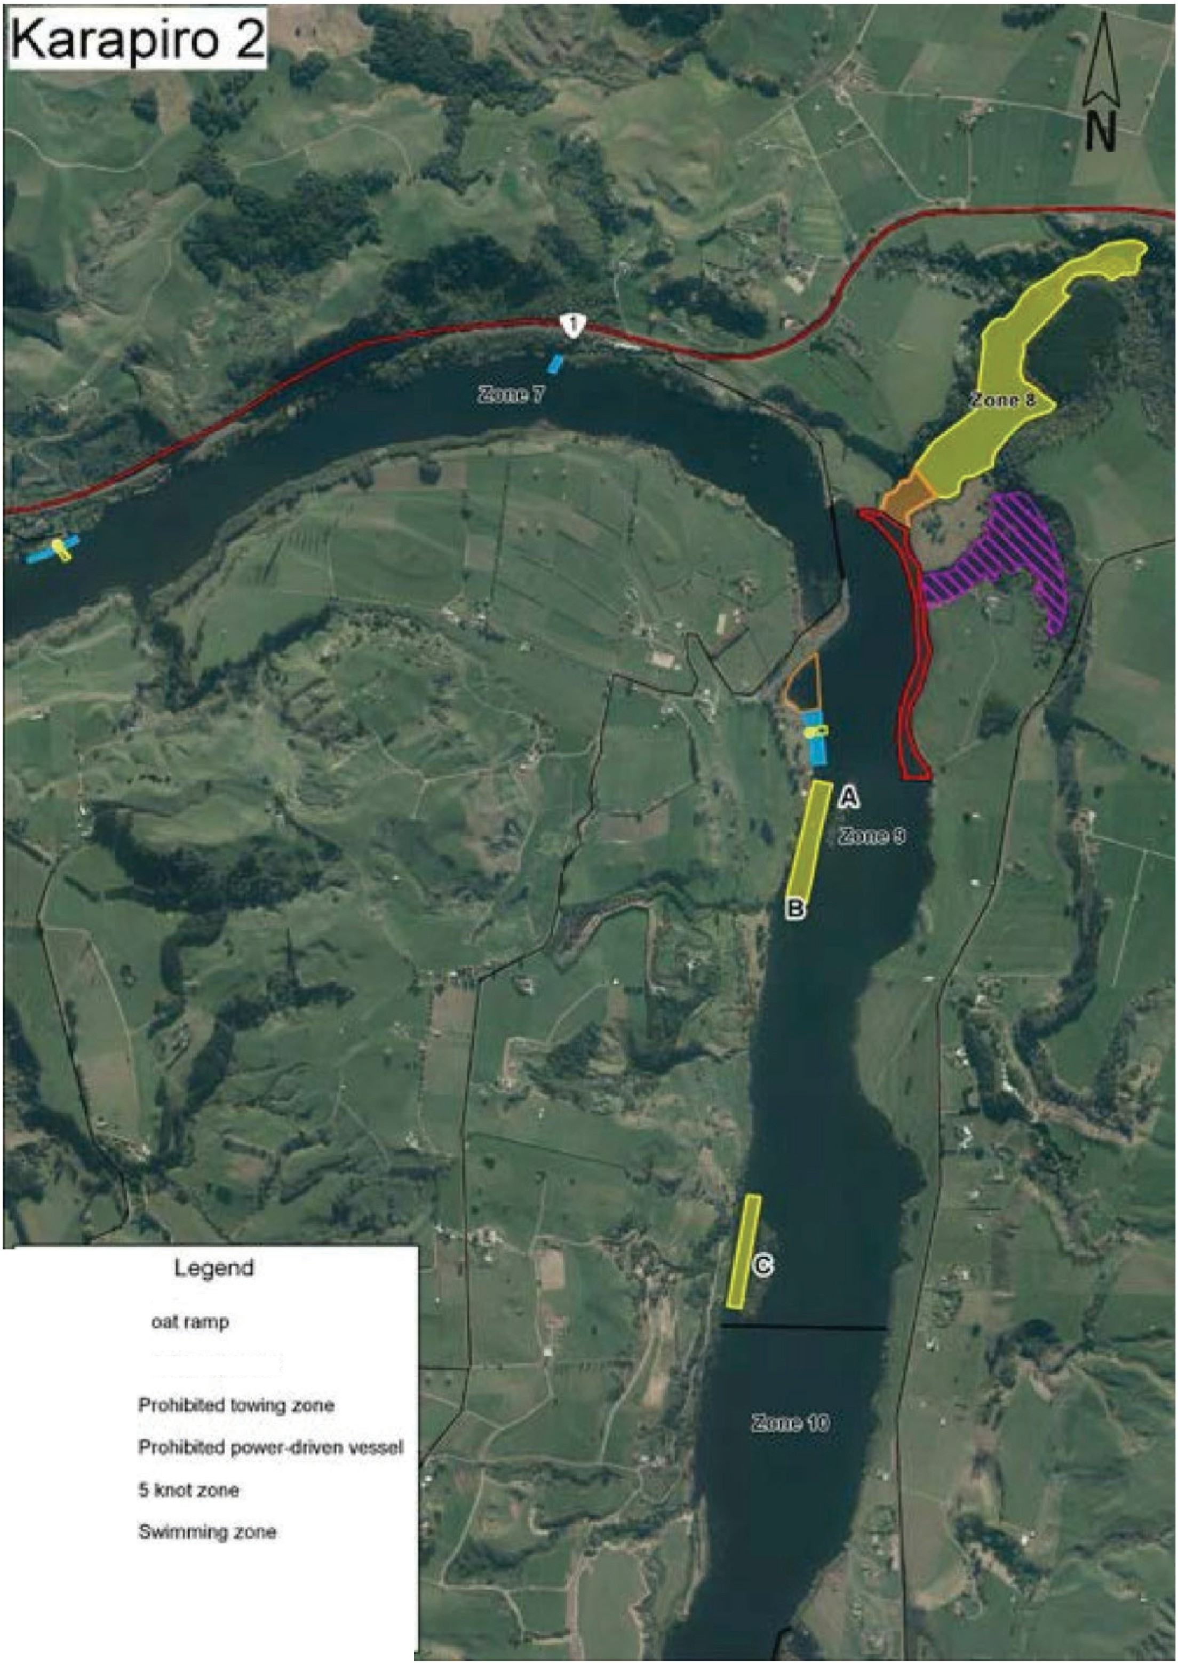

•

**B**

**B rillfflp 20Da**

**SllllOll'I *t jump* cotllSilli**

**T�**

**ll'CCC!!C! I lll!S**

Temporary Event Application

Page 20

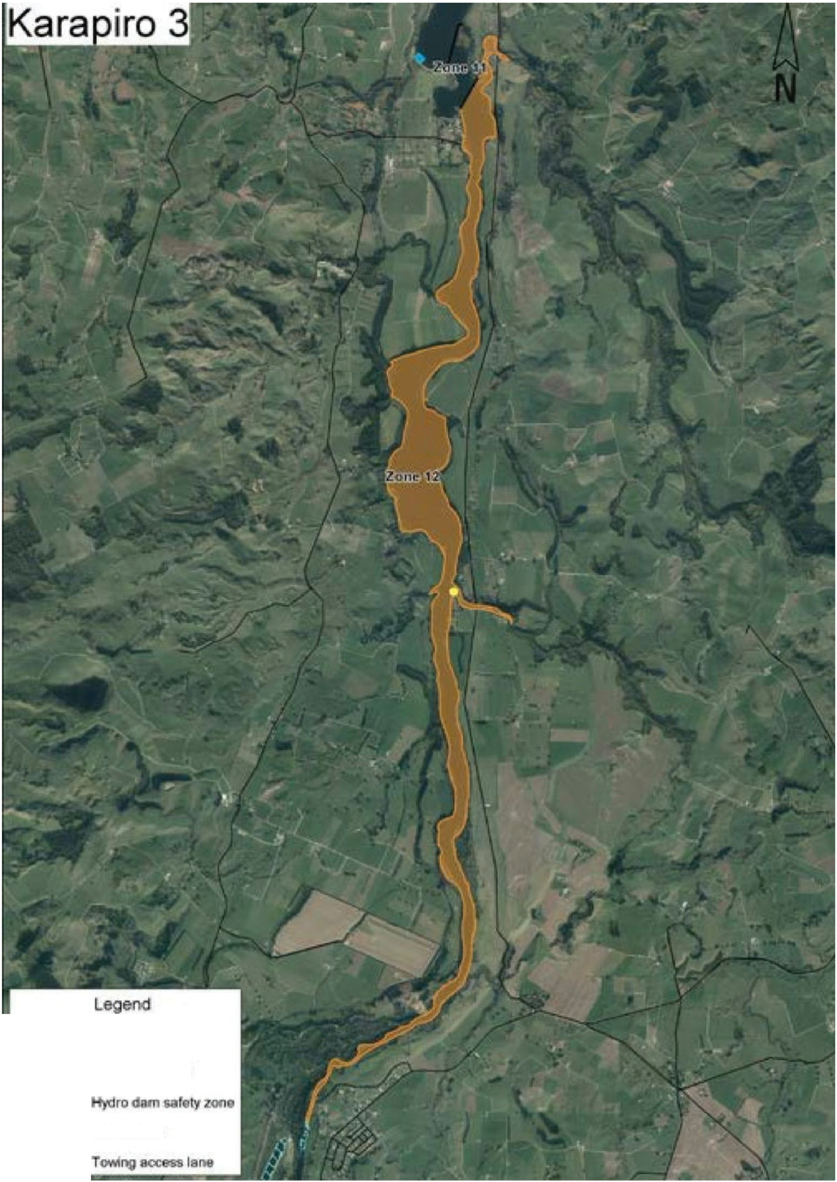

,,,• .......

**130.!**

**Boo**

**ramp**

-

**flUTIJ;IZQlll**

�\,,.'\..

-

**5**

**tzooe**

Temporary Event Application

Page 21